Recommended PC Purchases for Class of 2024
Contact Patty Rosenberger, Director of Technology
with questions prosenberger@gmahs.org

Latitude 7400 2 in 1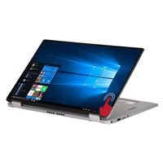  Core i5 Processor  256 GB Solid State Drive  14-inch touch screen  Express Charge  $1550 includes  4 years ProSupport  3 years McAfee Security | Latitude 5400  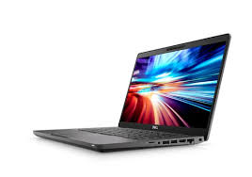  Core i5 Processor  256 GB Solid State Drive  14-inch screen  Express Charge  $1200 includes  4 years ProSupport  3 years McAfee Security
Inspiron 7000 2 in 1  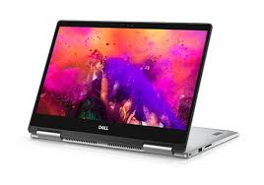  Core i5 Processor  512 GB Solid State Drive  13.3-inch touch screen  $1050 includes  4 years ProSupport  3 years McAfee Security | Latitude 7390  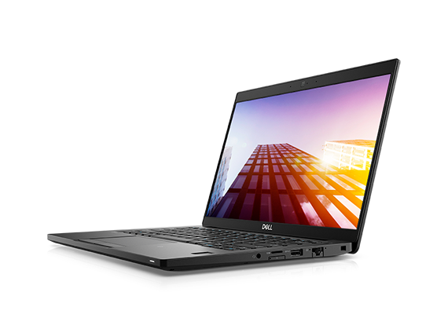  Quad Core i5 Processor  256 GB Solid State Drive  13.3-inch screen  Express Charge  $1050 includes  4 years ProSupport  3 years McAfee Security

Email will be forwarded to all freshmen families to purchase the above devices at special pricing for GMAHS families.

