Theology 9 Summer assignment
Summer assignment counts as your first grade in Theology. Please reach out to Ms. Szewczak at mszewczak@gmahs.org if you have any difficulty.

Catholicism 101 online course by St, Mary’s Press
Enrollment instructions for students:
1. Go to https://mlearn.smp.org/enroll
2. Enter the section code at the top: Your Section Code: 8m5x56hs
3. It will look like this:
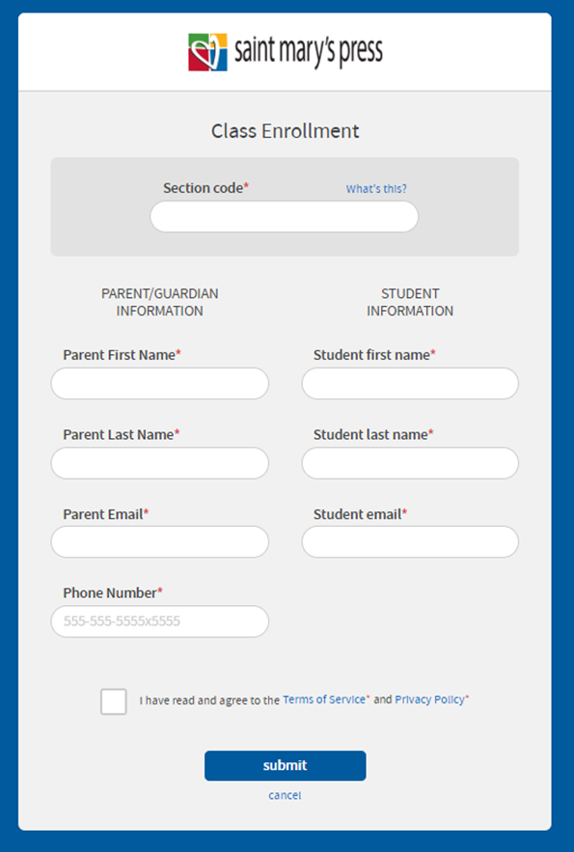
4. Fill in all the parent and student fields
5. Review and accept Terms of Service
6. Click Submit
7. This will take you to the payment screens.
8. Enter billing address
9. Click Submit
10. Enter credit card information
11. Click Place Order
Students should bookmark http://mlearn.smp.org to log in.

