Summer Assignment 2021
Honors Introduction to Engineering Online research and reflection essay
Again, please feel free to e-mail Ms. Kimberly Naucodie knaucodie@gmahs.org if you have any questions or concerns about this assignment.

We wish you a safe, happy summer and we look forward to seeing you again in the fall!

The Gwynedd Mercy Academy Mathematics Department

Introduction paragraph - This is a self reflection of what type of engineering you think you’re interested prior to starting research in understanding. What type of engineering? Why are you interested in this type? What has influenced you towards this area?
Detailed description and photos for each type of engineering: Complete an informational journal type essay on all the major types of engineering – 1) Mechanical, 2) Electrical, 3) Chemical, 4) Civil, and 5) Architecture (may or may not be engineering). Describe each category of engineering in detail using your own words (please reference reputable notable sources in MLA format at end of essay).
Engineers for each engineering type: Choose a famous engineer from each type of engineering and explain who they are and what they are noted for and include photos or other interesting criteria you found on them in your essay. You will be presenting this to the class so try to choose engineers who aren’t well known but should be in your opinion. You are their advocate so others in the class will get to know them. Post the engineer names you are using in teams so that we have many engineers that we will be discussing as a class. Extra points for diversity advocates supporting Sisters of Mercy Critical concerns this year.
Specialty engineering types: Choose at least an additional two types of specialty engineering that you may be interested in and delve deeper. Explain each type of engineering and where the noted schools are for education related to each type. See if you can find good descriptors of what these types of engineers do. Keep in mind that having a chosen specialty like this could limit your career possibilities especially if the field is transforming as we speak.
Reflection paragraph: Upon this research you have conducted, have any of your opinions changed on what you think you’d like to focus on. What type of engineering? Why did it change? Who or what influenced your opinion?
Rubric for grading: (see attached)
Date for presentation and turning it in: First day of class (you will present what you found and what it means to you to your class)
All essays will be submitted through Turnitin.com on the specified deadline and needs to be in green or yellow upon review. This will be set up first week of returning. All essays should have sources listed in MLA reference format attached to essay.

RUBRIC for Journal Essay Research on Engineering
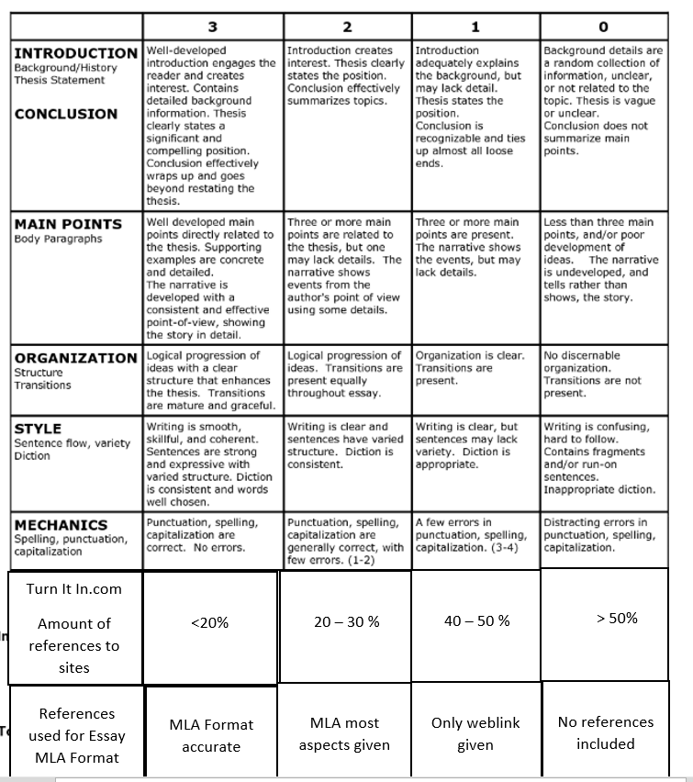
- Please make sure MLA References are complete. Points will be deducted if you do not include all parts of MLA reference criteria.

